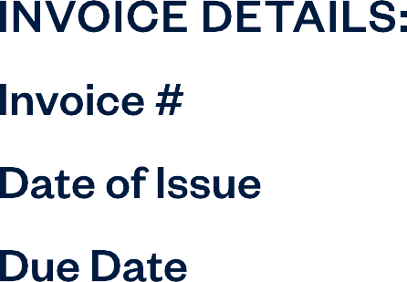0000

MM/DD/YYYY MM/DD/YYYY

**CUSTOMERNAME**

StreetAddressLine01

StreetAddressLine02



**BusinessName**

StreetAddressLine 01

StreetAddressLine 02

+1 (999)-999-999

Email Address

Website



|  |  |  |  |  |
| --- | --- | --- | --- | --- |
| **Placeholder** | Text | 000 | 000 | 000 |
| **Placeholder** | Text | 000 | 000 | 000 |
| **Placeholder** | Text | 000 | 000 | 000 |
| **Placeholder** | Text | 000 | 000 | 000 |

TextHere

|  |  |
| --- | --- |
| Subtotal | $00.00 |
| Discount | -$00.00 |
| Tax Rate | 5% |
| **Tax** | $00.00 |
|  | $00.00 |

CONDITIONS/INSTRUCTIONS

TextHere