TA-W51312 (11/2004)

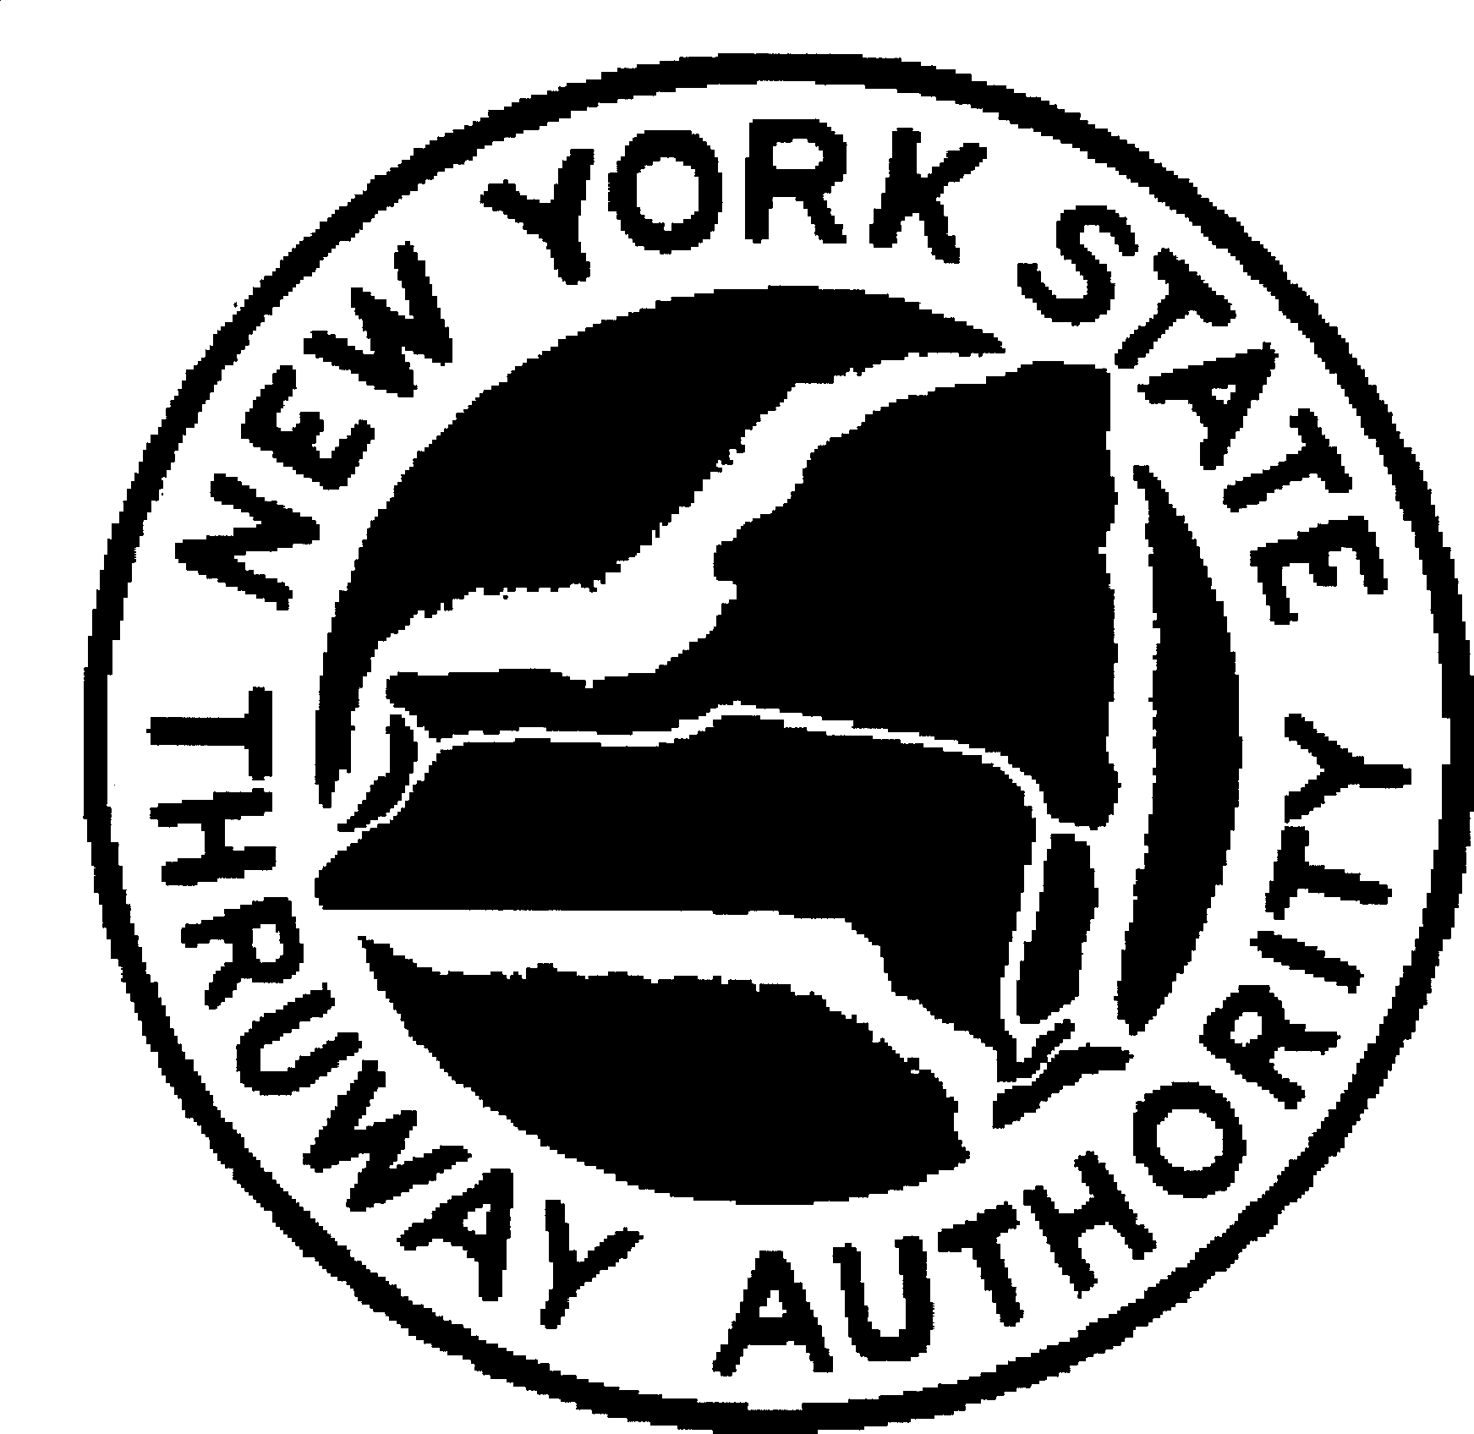Page 1 of 2

**Clear Form**

New York State Thruway Authority

Commercial Charge Account Number

For Office Use Only

CREDIT AGREEMENT

This Agreement is made this day of , 20 , between the New York State Thruway Authority, a public corporation organized and existing pursuant to Article 2, Title 9 of the

New York State Public Authorities Law, as amended, (hereinafter "Authority"), and

(hereinafter "Customer") a(n) (partnership) (corporation) (association)

duly organized and existing under the laws of the State of , having its principal

office at , or ,

(hereinafter "Customer") an individual doing business as , having a principal office at , and a home address

at .

# WITNESSESTH:

Whereas, the Authority operates the superhighway system known as the Thruway in the State of New York, and charges a toll for its use; and

Whereas, the Customer operates commercial motor vehicles which will, from time to time, travel between various interchanges of the Thruway; and

Whereas, for purposes of operating convenience and efficiency, the Customer requests the privilege of having an Authority Commercial Charge Account ("Account"); and

Whereas, the Authority, upon certain terms and conditions, is willing to grant such Commercial Charge Accounts to accredited commercial operators whose motor vehicles will use the Thruway.

Now, therefore, in consideration of the extension of credit and other valuable consideration, the Customer agrees as follows:

1. This Credit Agreement is not a consumer credit agreement within the meaning of Title 15, United States Code, Chapter 41 and shall be used only for business, commercial or agricultural purposes.
2. The Customer will file with the Authority a surety bond in an approved form or an interest-bearing cash deposit conditioned upon the Customer's prompt payment of invoices for toll trips, monthly E-ZPass Tag fees, special hauling permit fees and any other fees associated with travel on the Thruway. Such bond or cash deposit shall be in an amount equal to at least three (3) months billings for Thruway tolls and related charges or as determined by the Authority. Such bond shall be furnished without cost to the Authority. The Authority reserves the right to review the Customer's account at least monthly and to require an increase in such bond or cash deposit at any time. If the Authority notifies the Customer that an increased bond or cash deposit is required and states the amount of such increased bond or cash deposit, the Customer agrees to provide such increased bond or cash deposit within twenty (20) days after receipt of such notification. Failure to do so will result in suspension of the Account.
3. The Customer will pay, not later than thirty (30) days after the date of an invoice, all charges on the invoice including the established tolls for all trips recorded indicating passage on the Thruway, all charges for special hauling permits, charges for other specialized permitted uses of the Thruway system, and the fees applicable to the Customer's receipt and use of E-ZPass Tags.

TA-W51312 (11/2004)

Page 2 of 2

CREDIT AGREEMENT

1. In the event the Customer fails to make payment in full as required by paragraph 3 herein, the Authority will suspend the Customer's Account, and seek payment from the Customer's surety or the cash deposit. In such event, the Customer agrees to immediately cease use of all E-ZPass Tag(s). The Authority will refuse to honor such E-ZPass Tag(s) thereafter.
2. In the event the Customer is delinquent in making payment for invoices submitted, necessitating the Authority's initiation of legal action, the Customer agrees to reimburse the Authority for all fees and expenses which the Authority may incur, including reasonable attorney's fees and interest at the prevailing legal rate calculated commencing 30 days after the due date of the invoice.
3. This Agreement is at will and may be terminated by either party at any time. It shall be effective from the date of its execution until such time as either party hereto shall give notice of termination in writing to the other party. Such notice shall be given by Certified Mail, Return Receipt Requested, and shall be effective fifteen (15) days subsequent to the date of actual receipt of notice. In the event of such termination by either party, the Customer agrees to cease use of its E-ZPass Tag(s) and return all Tag(s) to the Authority. If the Customer fails to cease use of its E-ZPass Tag(s) or return all Tag(s), the Customer agrees to pay resultant charges within 30 days from the date of invoice. After such payment is made, this Agreement shall be deemed terminated.
4. The Customer agrees to incur a minimum annual charge as established by the Authority.
5. The Customer agrees to open and maintain a New York State Thruway Authority Pre-Paid E-ZPass Account.
6. Failure to comply with this Agreement and the terms and conditions of your Post-Paid and Pre-Paid Commercial Charge Account may result in immediate termination of the Customer's Account. In the event of such termination, the Customer agrees to cease use of its E-ZPass Tag(s) and return all Tag(s) to the Authority. If the Customer fails to cease use of its E-ZPass Tag(s) or return all Tag(s), the Customer agrees to pay resultant charges within 30 days from the date of invoice.

In WITNESS WHEREOF, the parties hereto executed this Agreement on the date first above written.

*Please indicate below type of billing preferred:* **NEW YORK STATE THRUWAY AUTHORITY**

Subtotal by Date

Subtotal by Tag

Authorized Signature

*Please indicate below type of mailing preferred:*

E-TRIP

# CUSTOMER

e-mail address required

Company Name/DBA

Additional e-mail address (optional)

US Mail

Authorized Signature (Original

Signature Required)

Name (Please type or print)

Title (Please type or print)