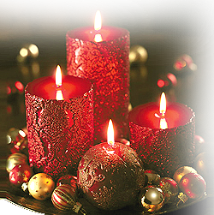

Let there be **Fun**

Let there be

**Party**

|  |
| --- |
|  |

|  |
| --- |
|  |

|  |
| --- |
|  |

|  |
| --- |
|  |

|  |
| --- |
|  |

|  |
| --- |
| **Mr. and Mrs. ---------------------------------**  **Invites you at** |

___________________________________________

Sunday, December 00, 2000

at 4:00 PM

Grafton High School Auditorium